**ACD_BDD_Project1.1**

**1. Associated Data Files**

**https://acadgild.com/blog/sentiment-analysis-on-tweets-using-afinn-dictionary/**

**2. Problem Statements**

Follow the below blog and perform sentiment analysis using MapReduce/Pig.

https://acadgild.com/blog/sentiment-analysis-on-tweets-using-afinn-dictionary/

Submit the screen shots of the final results with the source code.

**Solution**

Created flume configuration file.

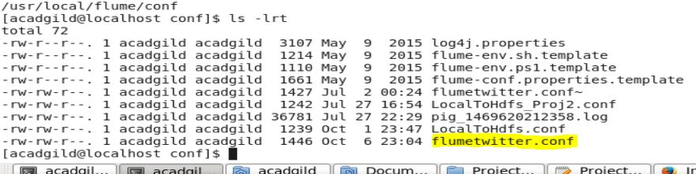

Configured flume conf file with consumer key and access token.

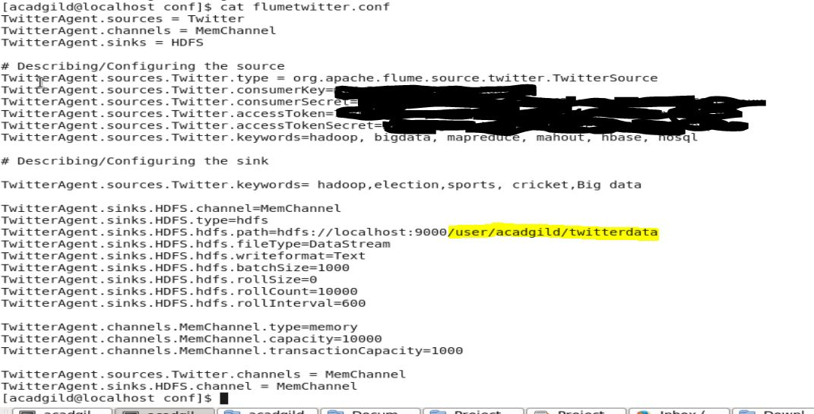

Stored streamed data in HDFS using below command.

**flume-ng agent -n TwitterAgent -f /usr/local/flume/conf/flumetwitter.conf**

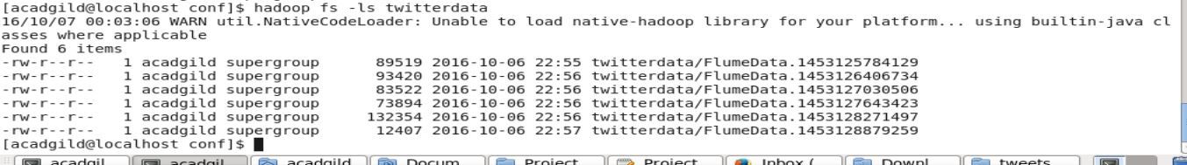

Stored tweets.

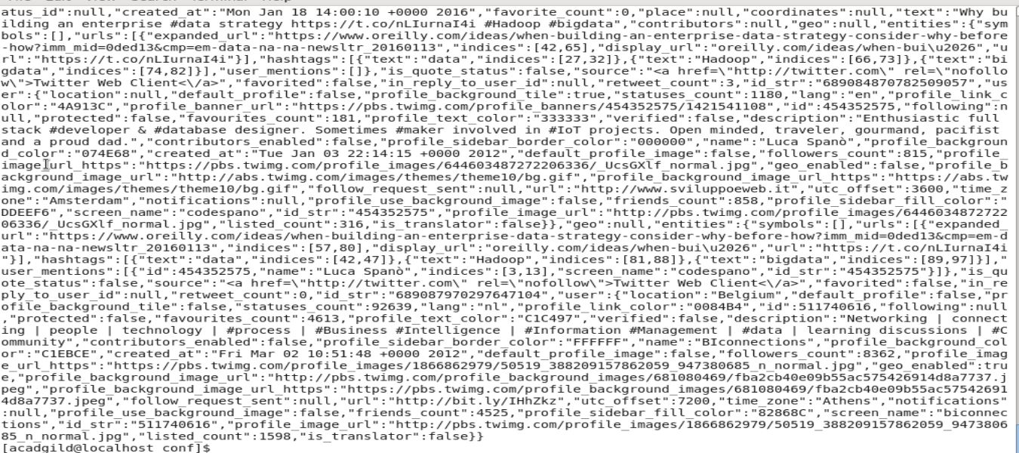

**Pig commands:**

REGISTER '/home/acadgild/Documents/Project1.1/elephant-bird-hadoop-compat-4.1.jar';  
REGISTER '/home/acadgild/Documents/Project1.1/elephant-bird-pig-4.1.jar';  
REGISTER '/home/acadgild/Documents/Project1.1/json-simple-1.1.1.jar';  
  
load_tweets = LOAD '/user/acadgild/twitterdata' USING com.twitter.elephantbird.pig.load.JsonLoader('-nestedLoad') AS myMap;

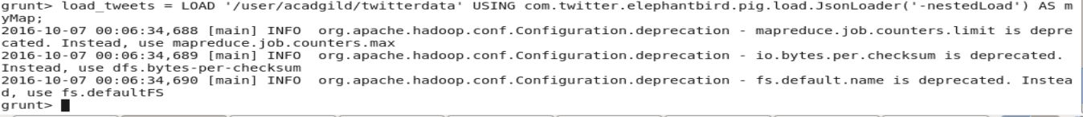

dump load_tweets;

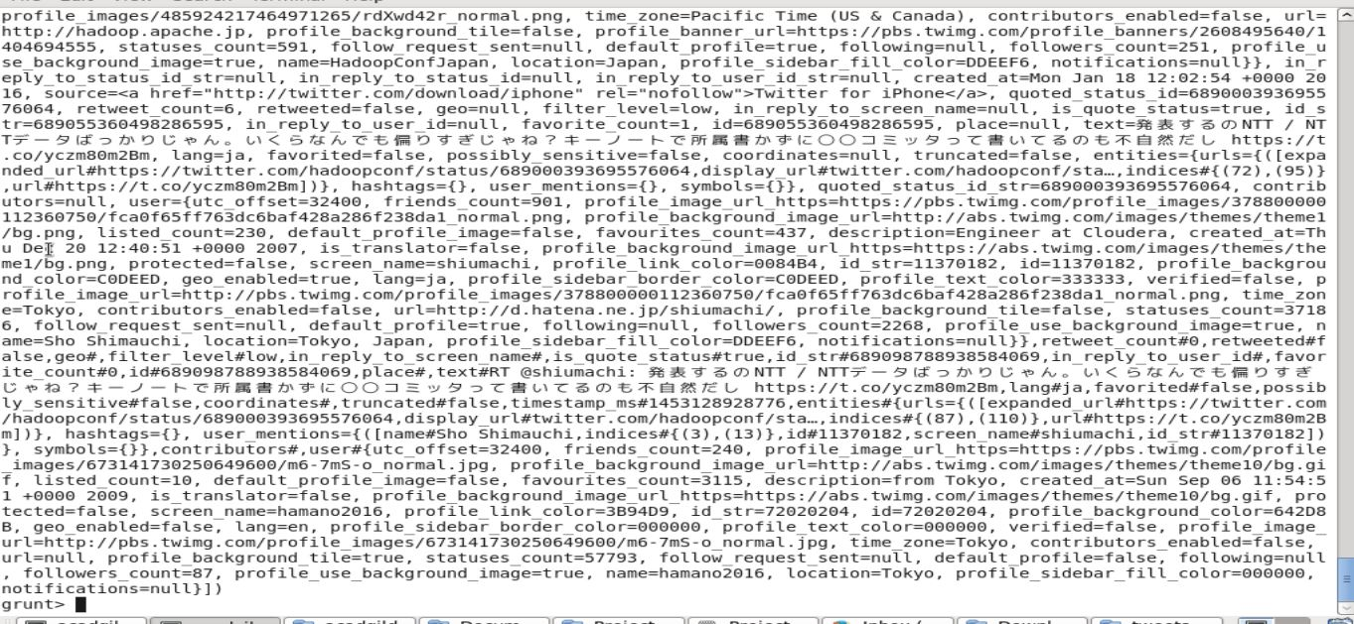

extract_details = FOREACH load_tweets GENERATE myMap#'id' as id,myMap#'text' as text;

C:\Users\RAKESH\Desktop\Screenshot\Project1.1\S8.JPG

dump extract_details;

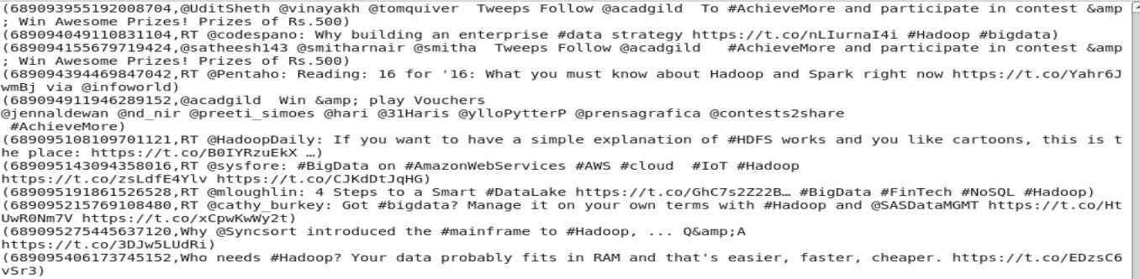

tokens = foreach extract_details generate id,text, FLATTEN(TOKENIZE(text)) As word;



dump tokens;

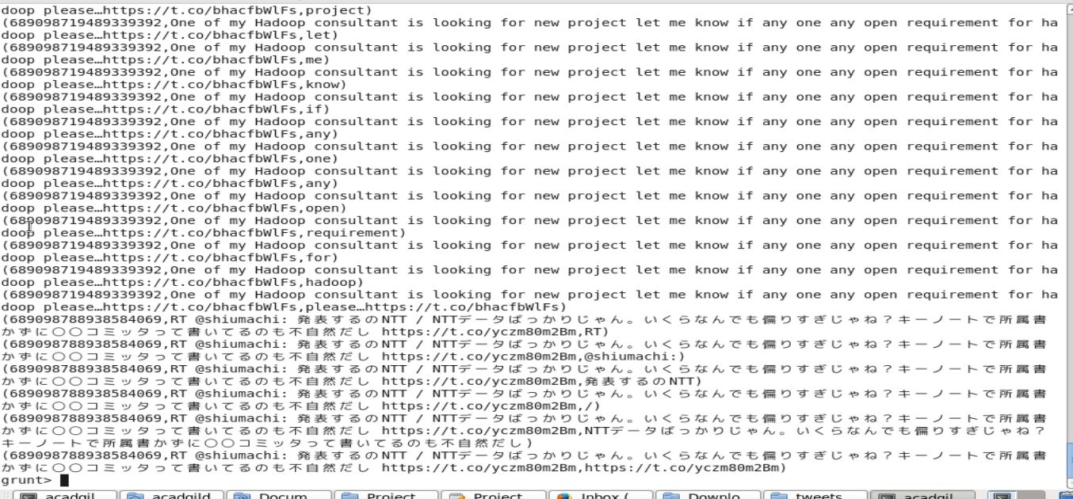

dictionary = load '/user/acadgild/afinn/AFINN.txt' USING PigStorage('\t') AS (word:chararray,rating:int);

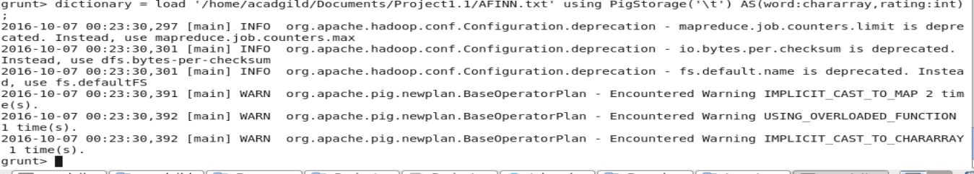

dump dictionary;

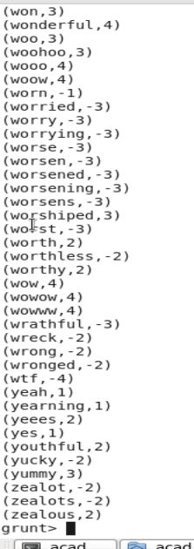

word_rating = join tokens by word left outer, dictionary by word using 'replicated';

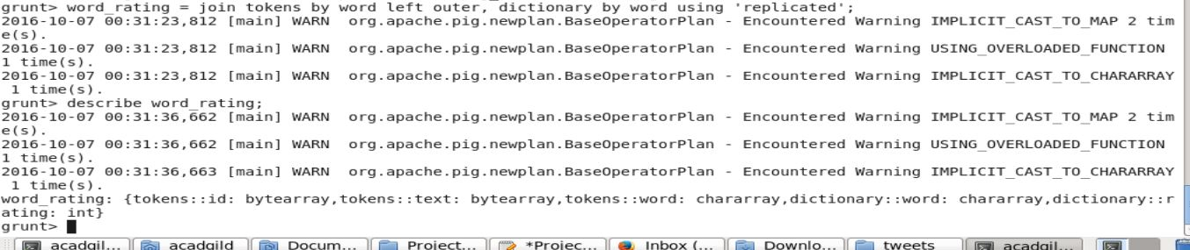

rating = foreach word_rating generate tokens::id as id,tokens::text as text, dictionary::rating as rate;

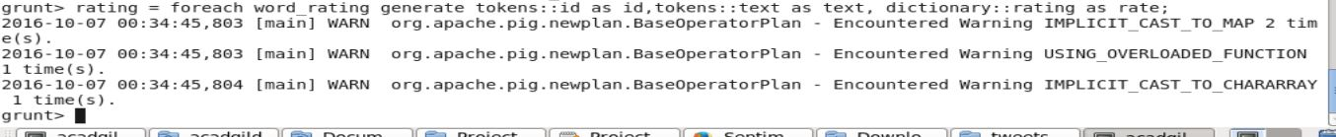

word_group = group rating by (id,text);

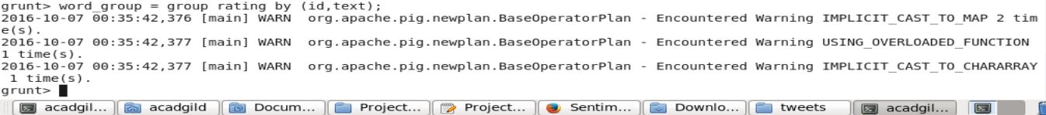

avg_rate = foreach word_group generate group, AVG(rating.rate) as tweet_rating;

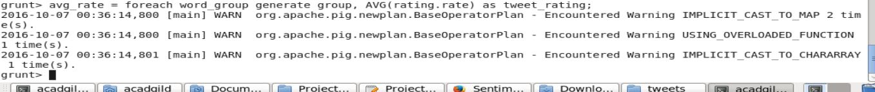

dump avg_rate;

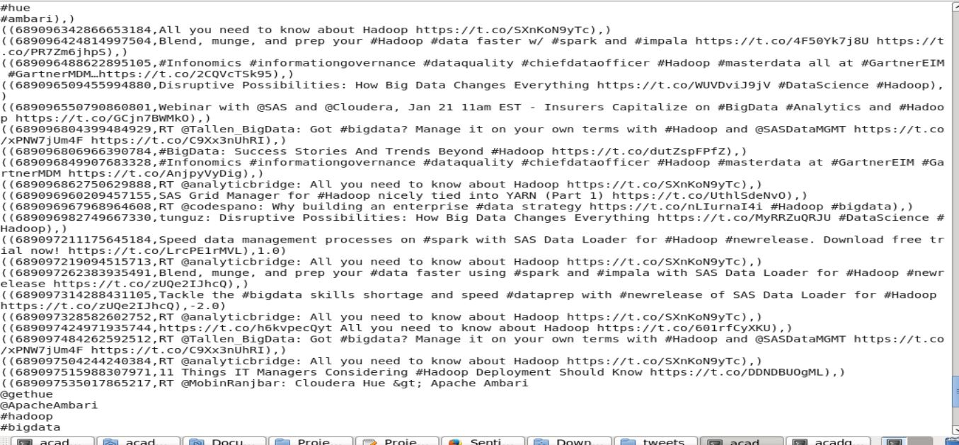

positive_tweets = filter avg_rate by tweet_rating>=0;

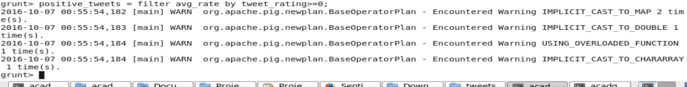

dump positive_tweets;

